**Final Project Draft Part - II SEIS630**

**Retail Store Point-of-Sale Database Project**

**Avinash Verma**

**UST ID – 101261924**

I am using a AWS database system for the **Point-of-sale** system and using MySQL workbench. The product has contained information about **Products, Sales Details, Inventory, Returns Details, Replenishment Order** and **User Login**. It can be used for any retail store point of sale billing system.

Now, I have created some points of this project. Please look below.

1. I am using AWS MySQL database instead of Oracle Cloud.
2. I have created database on AWS RDS MySQL.

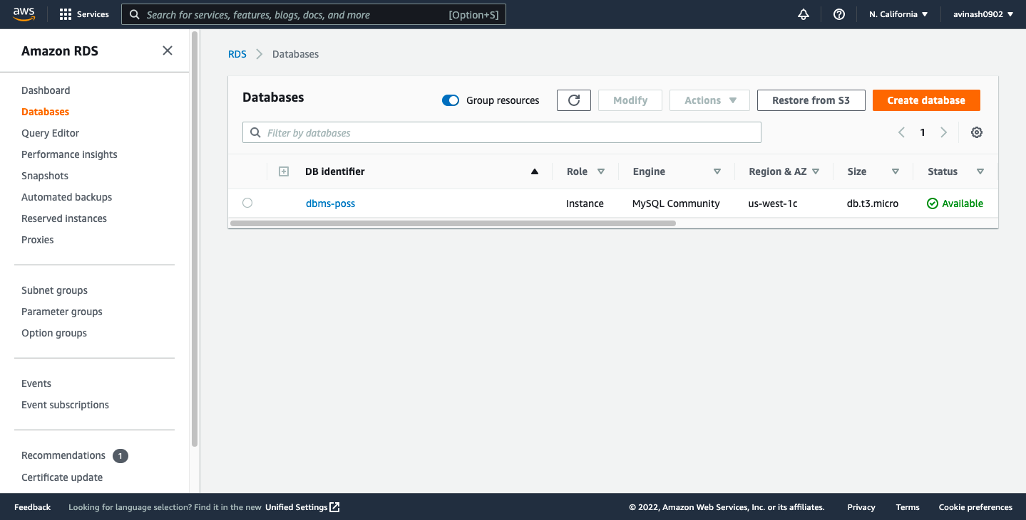

1. I am using MySQL workbench for SQL query.

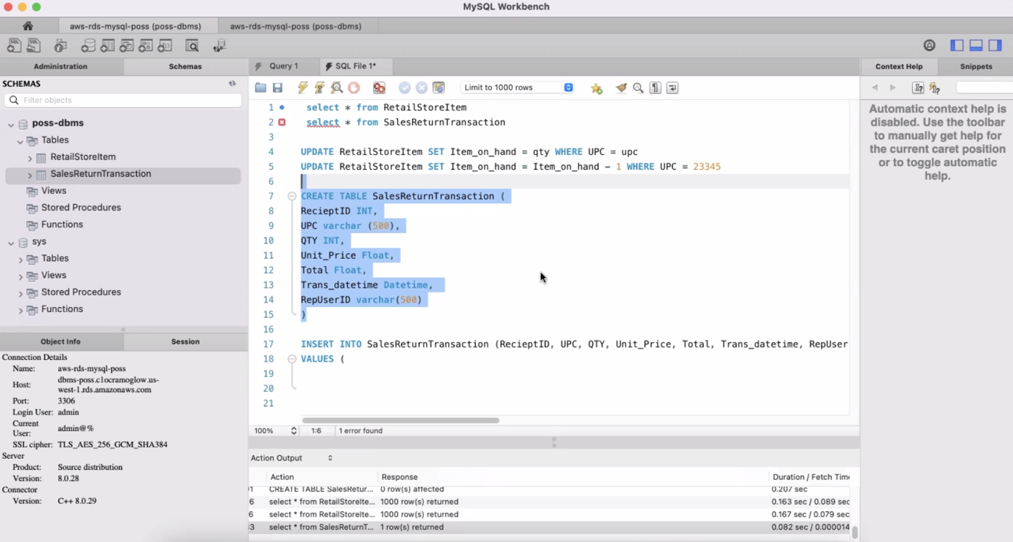

1. I am using AWS MySQL database and MySQL workbench to create tables and populated the database by using MySQL insert statements.

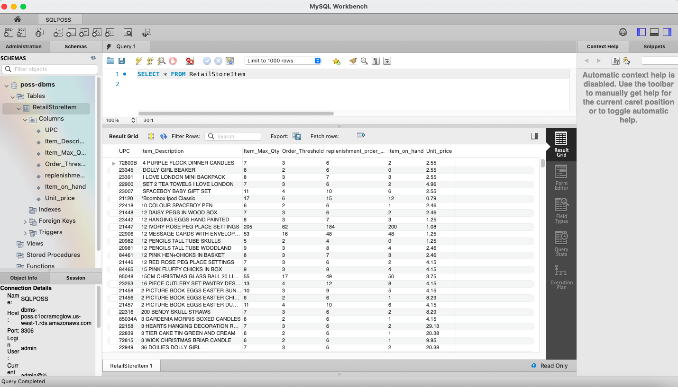

1. I have connected python code with AWS MySQL Database.
2. Developed a collection of non-trivial and application oriented queries, addressing user needs and correct implementation in AWS database.

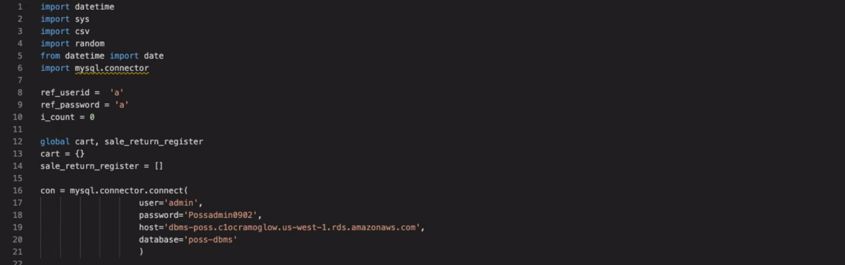

1. I have written an interface in python. The main interface and functionalities has contained new sales, return items.

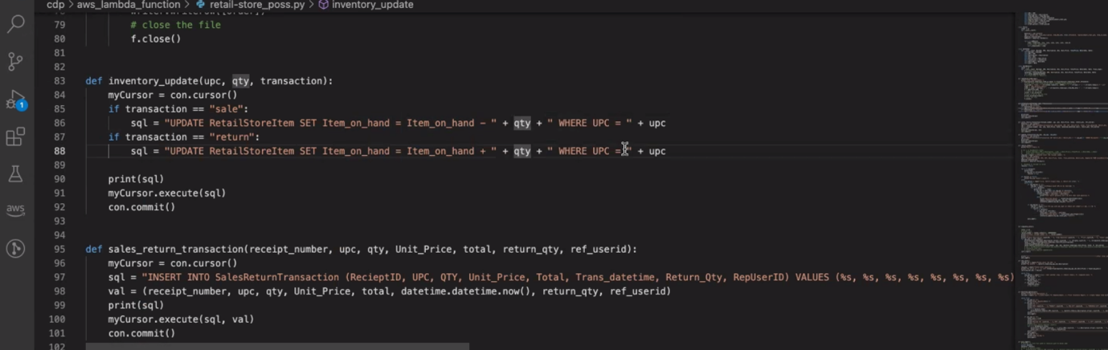

1. Backroom operations python interface is in process.
2. The python interface is updating the Retail store table and automatically replenish the inventory table.

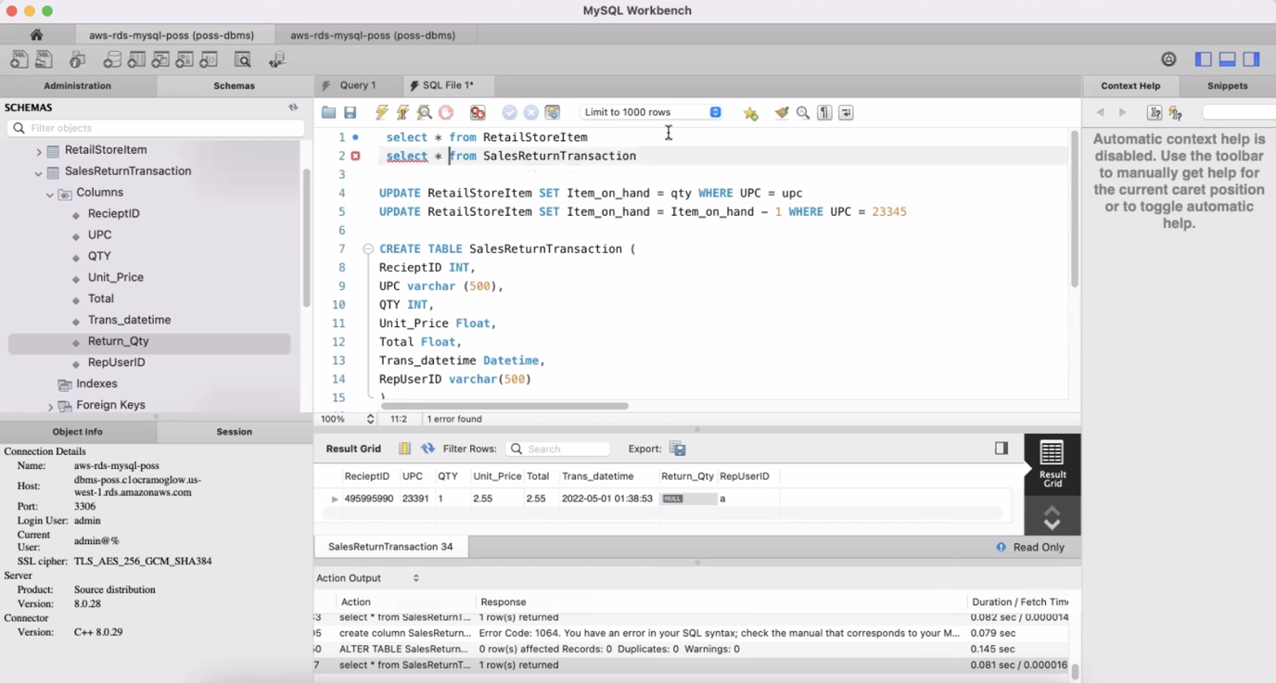

1. Application security secured by user authorization is in process.

The database and python interface connection has been done using AWS RDS MySQL database.